Internship 2022

# Progress report format for team meeting

Name: ALLAN WERE

## Tasks completed last week

* [#79] Powering the raspberry pi board.

A 5V power bank should be provided so as to power the raspberry pi on the robot separately.

This will ensure that it counters for the voltage drop issues and provide the sufficient current for the components in the using power directly from the board eg ultrasonic and servo motor.

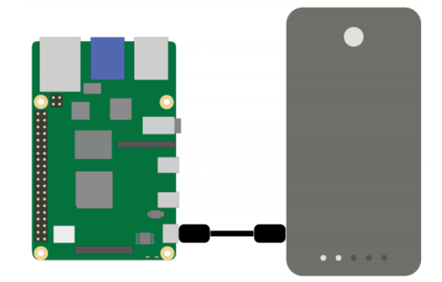

Figure power bank and raspberry pi schematic

* [#80] Working on the robot program to run effectively

As it was noticed that the program running robot had some issues, the team has worked to clear the issues and the program is currently running. The errors earlier may have been caused by the logic or compiling issues.

* [#81] Mounting of the power bank and the raspberry board on the robot chassis

The power bank will be mounted at the bottom and the raspberry on the rear side of the robot.

## Tasks in this week

* [#83] GPS and raspberry pi

# Timeline

|  |  |  |
| --- | --- | --- |
| Month | Intern week | Tasks |
| Jan |  |  |
| Week 1 | Identification of parts and drawing of the chassis diagram. |
| Week 2 | Circuit diagram and acquisition of parts. |
| Week 3 | Definition of the path to be followed by the robot car.  Laser cutting of the parts. |

|  |  |  |
| --- | --- | --- |
| Feb | Week 4 | * Assembly of the robot * Ultrasonic program implementation |
| Week 5 | * GPS and compass navigation * Path definition |
| Week 6 | Object identification using computer vision. (Raspberry pi & camera) |
| Week 7 | Transmission of live feed and data from the robot (transmitter and receiver) |
|  | Week 8 | Object dection (static and dynamic) |